**Findings :**

1. **State wise distribution of given data:**

We are provided with data from 233 school districts around the USA. For every school district we are given the state it belongs to, and we can see from the graph below that we are given most school districts from Connecticut followed by Utah and Massachusetts.

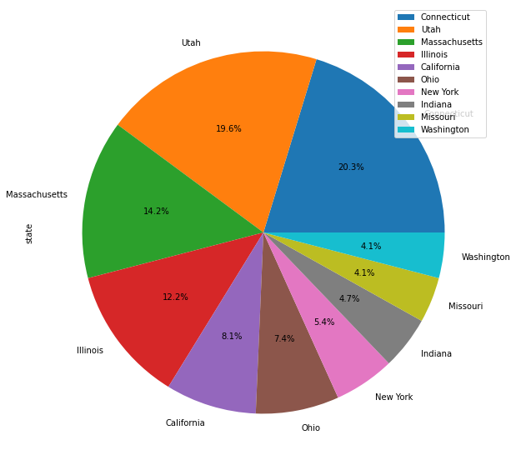

1. **Distribution of locale - (suburban, rural, city, town)**

According to NCES, US territory is divided in 4 locales and we are given for every district which locale it belongs to. It is clear from the graph below that for our data most districts belong to suburban areas.

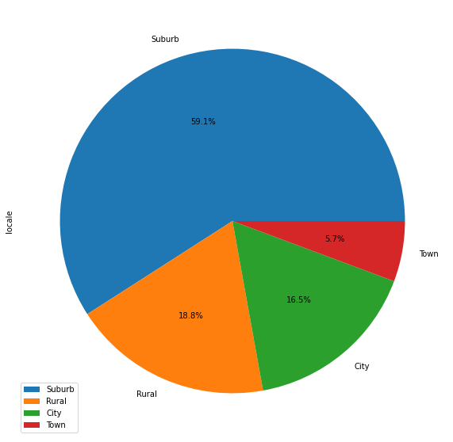

1. **Companies that are providing products for online education:**

It is clear from the graph below that google provided the most learning products(33) followed by microsoft(6), houghton(6).

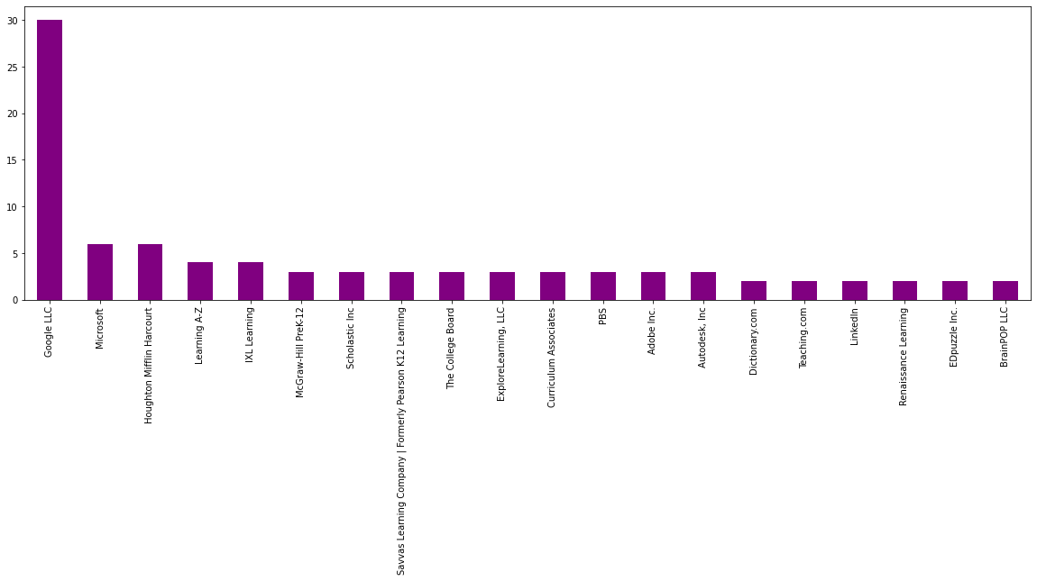

1. **Sectors in which companies are active:**

The graph below shows that most digital learning providers are active in sector PreK-12 (48.3%+32.7%+18.5%=99.5)and very few(0.5%) in Corporate sector.

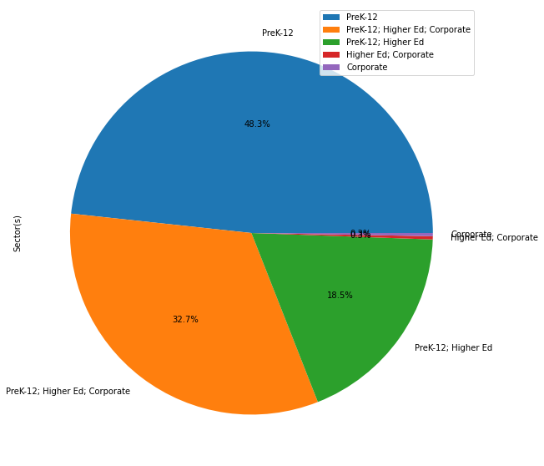

1. **Primary Function (main) of the products provided by different companies:**

LC = Learning & Curriculum, CM = Classroom Management, and SDO = School & District Operations

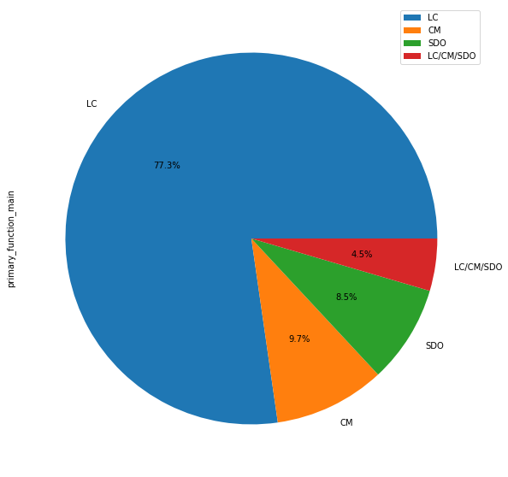

1. **Primary Function (Sub) of the products:**

For every product their sub function is also defined which is sub category of main function, distribution of which is shown in graph below:

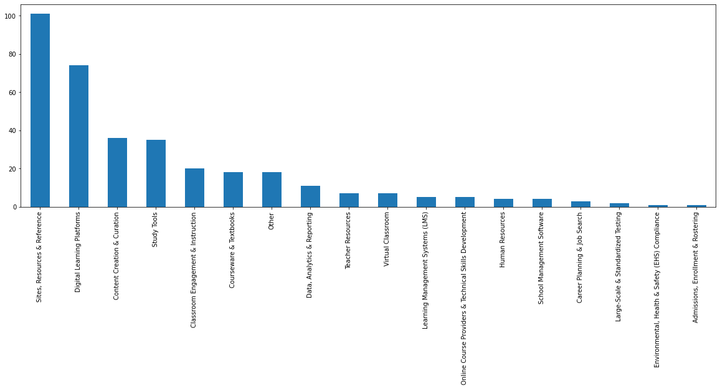

1. **Engagement of Virtual classroom Provider products over given period of time :**

Engagement is defined as - Total page-load events per one thousand students of a given product and on a given day

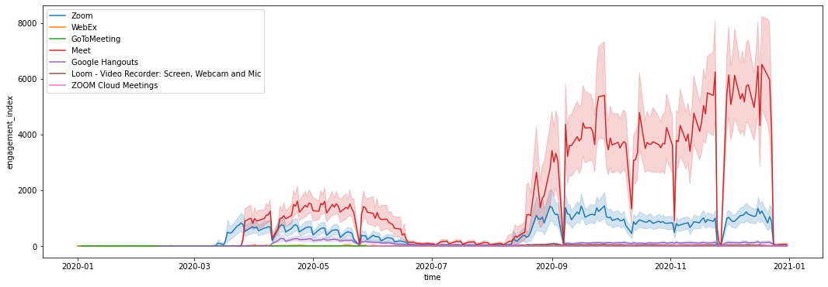

1. **Pct_access for Virtual classroom Provider products over given period of time**:

Pct_access is defined as- Percentage of students in the district who have at least one page-load event of a given product and on a given day.

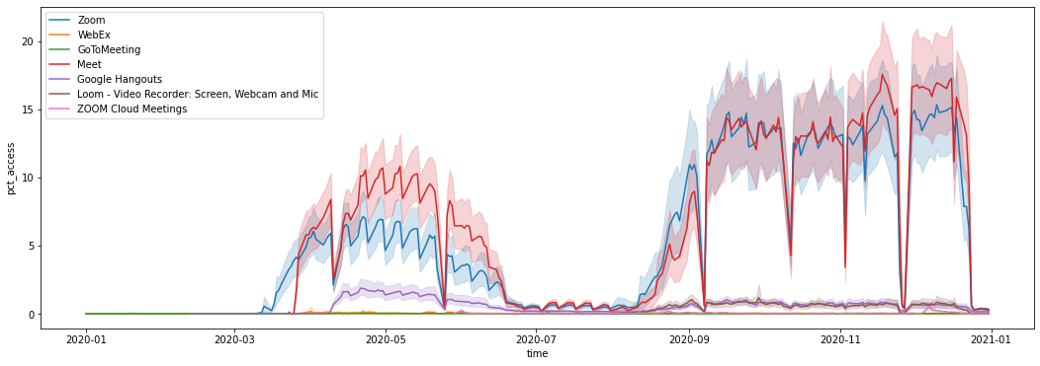

We can observe from the graph that meet, zoom and hangouts are the most prominent products here and show the most engagement and pct_access.

1. **Engagement_Index over the given time period:**

In the graph below there is a clear jump in engagement index around march 2020 (Start of pandemic). There is a dip around july 2020 due to summer holidays and then it increases again.There are random dips in the graph at a few places , which are probably because of national holidays/bank holidays.

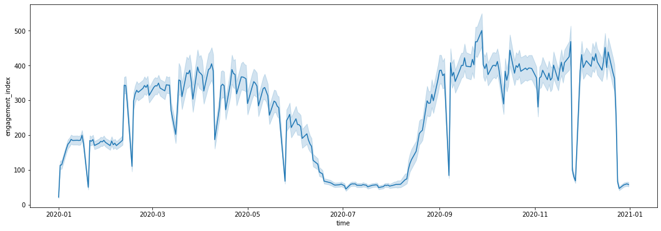

1. **Pct_access over given time period:**

From the graph below, we can see that march 2020 was the start of covid 19 pandemic which reduced pct_access a bit. July 2020-august 2020 was summer holidays and that is why pct_access is close to zero around that time and after that it has increased. There are random dips in the graph at a few places , which are probably due to national holidays/bank holidays.

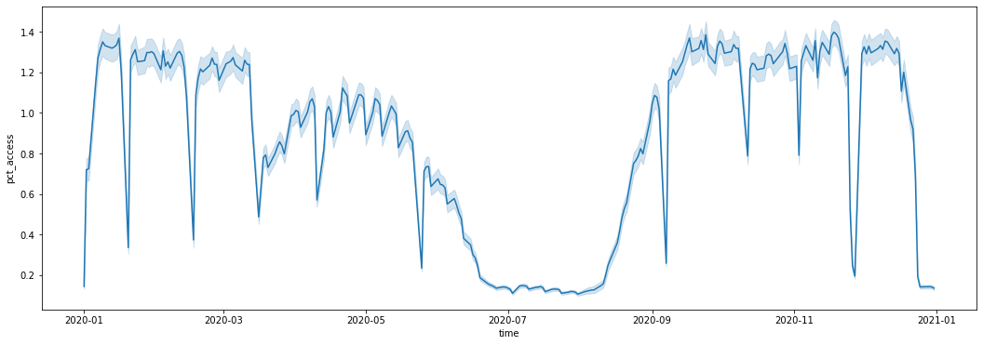

1. **Change in pct_access and engagement index from first quarter of 2020 (before covid) to last quarter of 2020(after second wave of covid) of primary function sub of products:**

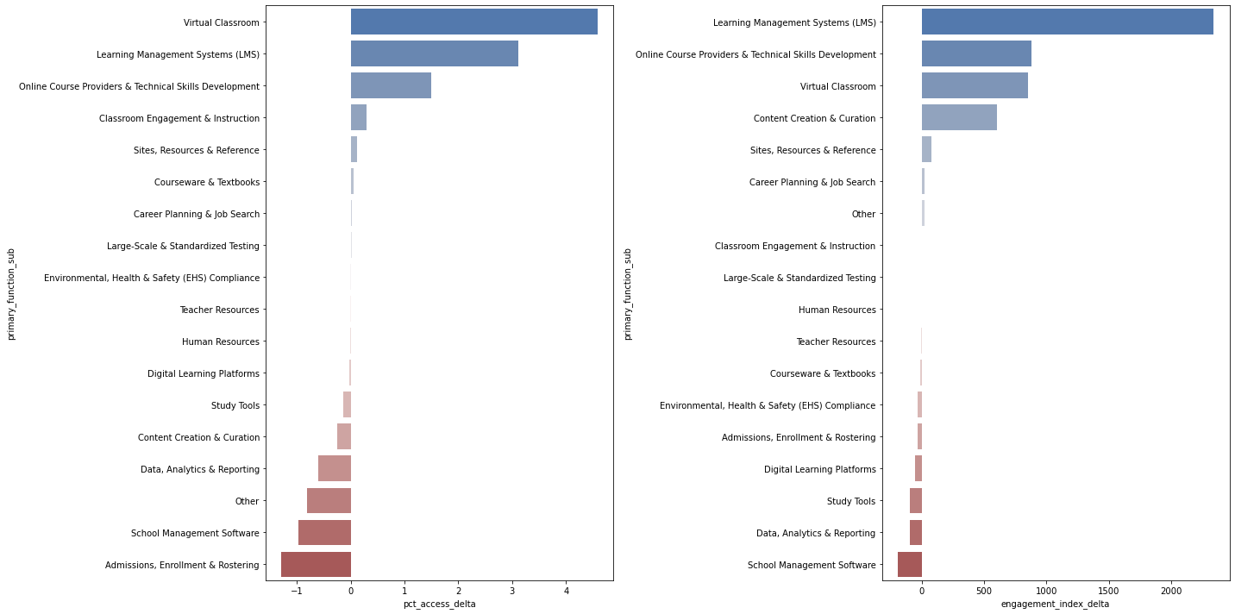

1. **Change in pct_access and engagement index from first quarter of 2020 (before covid) to last quarter of 2020(after second wave of covid) of products:**

Here youtube is in top in both graphs, but that could be because it was used for entertainment purposes as well.

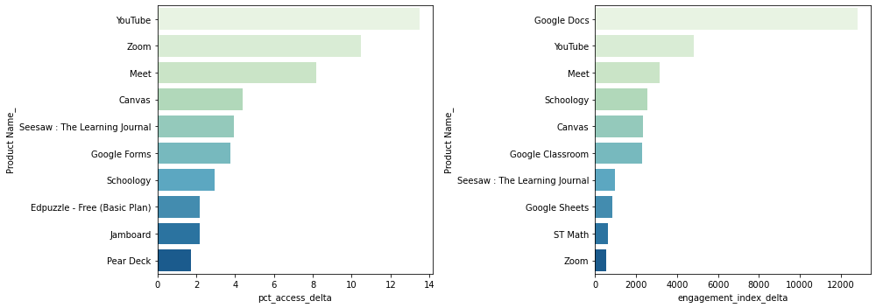

1. **Engagement Index (mean) for Different States:**

Arizona and Newyork have the highest engagement index among all the states.

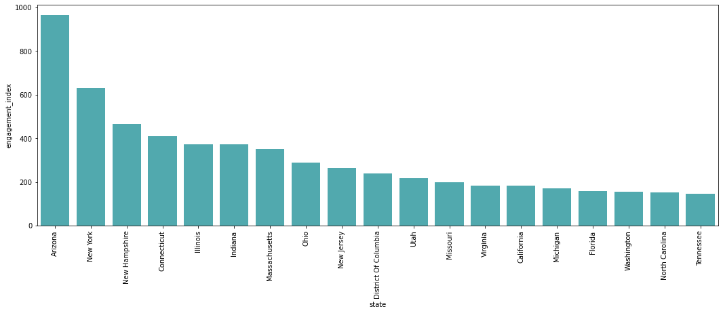

1. **No. of districts vs pct_black/hispanic and pct_free/reduced:**

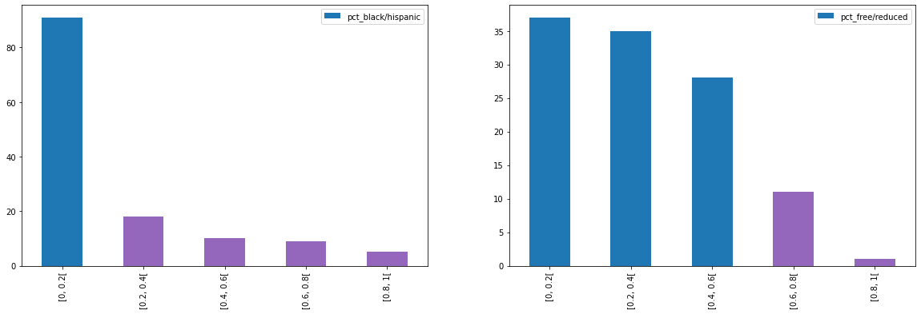

1. **pct_access and engagement vs Percentage of students in the districts identified as Black or Hispanic-**

We are getting districts with the most black/hispanic % in top here because we are given very few districts in that bin.

Rest, We can observe that districts with least black/hispanic student percentage have the maximum engagement index and pct_access, and districts with more black/hispanic student % have the least engagement and pct_access, and are the most vulnerable.

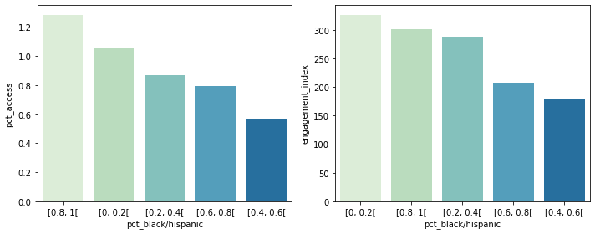

1. **Pct_access and engagement vs Percentage of students in the districts eligible for free or reduced-price lunch:**

There is an inverse correlation between the percentage of students who are eligible for free lunch and the engagement index. The less the pct_free/reduced the more the engagement and pct_access. We see the that 80-100 % bin is also in the top but that is because we are given very few districts in that bin.

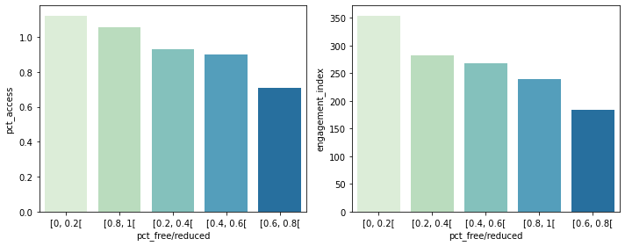

1. **Engagement index vs Per-pupil total expenditure :**

We can observe that there is a direct relationship between engagement and per-pupil total expenditure. The more the expenditure the more the engagement.

